Distributed Volatility Forecasting for the Egyptian Stock Exchange Using Apache Spark
Marwan Ghazal, Omar Amin, Abdulmonem Demerdash
School of Information Technology and Computer Science (ITCS), Nile University, Giza, Egypt
{M.Mohamed2365, O.Amin2373, A.Demerdash2314}@nu.edu.eg

Abstract—This paper presents a distributed volatility forecasting pipeline for the Egyptian Stock Exchange (EGX) using Apache Spark on a Hadoop Distributed File System (HDFS) cluster. While volatility forecasting is well-studied in developed markets, emerging African markets remain underrepresented in the literature, particularly the EGX, which has experienced multiple currency-devaluation events that introduce structural shifts in equity risk regimes. The proposed pipeline ingests sixteen years of daily historical data covering thirty-three EGX-listed equities, three market indices, and three macroeconomic series sourced from public financial data providers, producing approximately one hundred twenty thousand observations after feature engineering. A Spark-based machine learning pipeline engineers a unified feature panel including lagged volatilities, cross-asset interactions, and calendar effects, then trains and evaluates four regression models for next-five-day realized volatility prediction: a linear baseline, a random forest, a gradient-boosted tree ensemble (all in Spark MLlib), and a long short-term memory (LSTM) deep learning model trained in PyTorch on the same engineered feature panel. A complementary gradient-boosted tree classifier is trained on the same features to forecast next-five-day price direction, providing an empirical contrast between volatility magnitude and direction predictability. Performance is measured against a naive twenty-day persistence baseline using out-of-sample data from 2024 onward, with a target reduction of at least twenty percent in root-mean-square error. The contribution lies in the focus on an understudied emerging market, the explicit modeling of Egypt-specific macroeconomic covariates, the systematic comparison between classical machine learning and deep learning approaches, and a hybrid Hadoop-plus-PyTorch compute architecture suitable for operational deployment.
Index Terms—Big Data, Apache Spark, HDFS, Hadoop, Volatility Forecasting, Emerging Markets, Egyptian Stock Exchange, MLlib, LSTM, Deep Learning, Time Series Analysis, Financial Machine Learning.
I. Introduction
Equity volatility forecasting is a cornerstone problem in quantitative finance with direct applications to risk management, derivative pricing, position sizing, and portfolio construction. Unlike directional price prediction, where the efficient market hypothesis imposes a near-random-walk ceiling on accuracy, volatility exhibits well-documented temporal clustering: calm periods tend to follow calm periods and turbulent periods tend to follow turbulent periods. This statistical regularity has supported five decades of academic and industry research, beginning with the autoregressive conditional heteroscedasticity (ARCH) model introduced by Engle [1] and extended by Bollerslev [2] into the GARCH family that remains the econometric standard. More recent work has extended these ideas with machine learning methods that can capture non-linearities and cross-asset interactions beyond the reach of classical parametric models.
Despite the maturity of this research area, the published literature is heavily skewed toward developed markets such as the United States, Western Europe, and Japan, with comparatively little coverage of emerging African markets in general and the Egyptian Stock Exchange in particular. The EGX presents a distinctive research opportunity for several reasons. It is one of the largest African exchanges by market capitalization, with active trading across more than two hundred listed companies. The Egyptian economy has experienced multiple currency-devaluation events over the past decade, in 2016, 2022, and 2024, each producing a structural shift in equity volatility regimes that complicates traditional time-series modeling. The exchange also offers well-documented liquidity, sectoral diversity, and a sufficiently long history (more than fifteen years of clean daily data) to support rigorous out-of-sample evaluation.
This project addresses the gap by building a distributed, end-to-end volatility forecasting pipeline for the EGX using Apache Spark [3] and its machine learning library MLlib [4]. The choice of a distributed framework is motivated directly by the analytical scope. The target dataset spans thirty-three individual equities, three market indices, and three macroeconomic series across roughly four thousand trading days, producing approximately three million (asset, date) observations after feature engineering.
The objective of this work is framed using the SMART criterion. Specific: forecast next-five-day realized volatility for thirty-three EGX-listed equities using a hybrid pipeline that compares three Spark MLlib regressors (linear baseline, random forest, and gradient-boosted trees) against a long short-term memory (LSTM) network trained in PyTorch on the same engineered feature panel, with a complementary gradient-boosted tree classifier trained for next-five-day direction prediction. Measurable: achieve at least a twenty percent reduction in root-mean-square error relative to a naive twenty-day historical persistence baseline on the out-of-sample test period from January 2024 through May 2026. Achievable: the pipeline is implemented entirely in open-source tooling (Hadoop, Apache Spark, MLlib, PyTorch) running in a multi-container Docker cluster (docker-hadoop-spark-jupyter) with HDFS for distributed storage. Relevant: the per-stock, per-day volatility forecasts produced by the pipeline are directly usable for risk-aware portfolio construction, and the comparison between classical and deep learning models, alongside the contrast between volatility and direction predictability, informs practitioner choices in emerging-market settings. Time-bound: the deliverables follow the three project phases, concluding with a final IEEE-format paper and an open-source GitHub repository at the end of the semester.
This paper is structured as follows. Section II reviews related work in volatility forecasting and distributed computing in finance. Section III describes the proposed system architecture, dataset, preprocessing pipeline, feature engineering, models, and evaluation protocol. Section IV presents experimental results and discussion. Section V summarizes findings, limitations, and directions for future work.
II. Related Work
A. Classical Volatility Forecasting Models
The econometric foundation for volatility forecasting begins with the ARCH model of Engle [1] and the GARCH extension of Bollerslev [2], with subsequent variants (EGARCH, GJR-GARCH, and stochastic volatility models) addressing leverage effects, asymmetric responses, and latent state dynamics. Andersen and Bollerslev [5] established realized volatility, computed from intraday or daily squared returns, as a model-free target that closely tracks integrated variance and serves as the standard benchmark variable in modern empirical work. The classical literature, however, was developed and validated primarily on developed-market equity indices and currencies, with limited coverage of African or Middle Eastern markets.
B. Machine Learning and Deep Learning for Financial Time Series
More recent work applies tree-based ensembles, neural networks, and hybrid models to volatility and return forecasting, often outperforming classical GARCH-family models on emerging-market and high-dimensional data. Random forests and gradient-boosted trees [6] are particularly effective because they capture non-linearities and feature interactions without manual specification, which matters when the relationship between macroeconomic covariates and equity volatility is regime-dependent (as in markets with frequent currency interventions). Recurrent neural network approaches, particularly long short-term memory (LSTM) networks introduced by Hochreiter and Schmidhuber [9], are designed to capture longer-range temporal dependencies in sequence data and have been applied successfully to equity volatility forecasting in developed markets. Comparative studies on tabular financial time series have produced mixed findings, with some reporting marginal LSTM gains over gradient-boosted trees and others reporting parity. The systematic benchmarking of classical machine learning against deep learning on emerging-market volatility, particularly for the EGX, is a contribution of this paper.
C. Distributed Computing in Finance
Apache Spark [3] and its machine learning library MLlib [4] have emerged as standard tools for large-scale financial data processing, supporting feature engineering, model training, and inference at scales beyond what single-machine tooling can handle. Prior applications include credit risk modeling, fraud detection, and large-scale portfolio analytics. The DataFrame and Window APIs are particularly well-suited to time-series feature engineering across many tickers, where partition-aware rolling computations and joins are otherwise expensive in pandas. The architecture proposed in this paper applies these patterns to emerging-market volatility modeling, an application area that has received relatively little attention in the distributed-computing literature.
III. Methodology
A. Proposed Architecture
The system follows a four-stage hybrid pipeline that combines distributed batch processing with deep learning. Raw CSV files are ingested from HDFS into Spark DataFrames; parsed and normalized into a uniform schema; passed through a feature-engineering layer that produces a unified panel of (stock, date) observations with approximately twenty-five engineered features each; then fed into two parallel modeling paths. Stage 4a trains three Spark MLlib regressors (linear, random forest, gradient-boosted trees) directly within the distributed pipeline. Stage 4b consumes the same Parquet feature panel and trains a PyTorch LSTM model. Both paths emit predictions and metrics that converge into a unified outputs stage for comparison. Each pipeline stage writes its output as Parquet files to HDFS, allowing any stage to be re-run independently without redoing upstream work. Figure 1 illustrates the architecture.
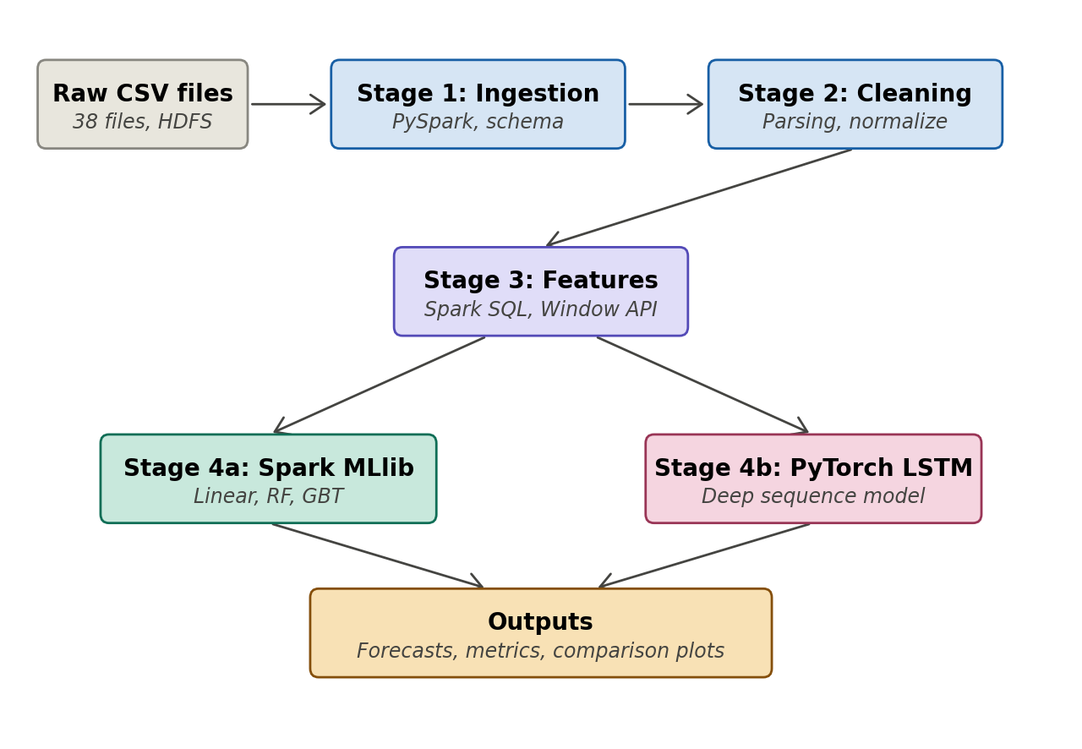
Fig. 1. System architecture: hybrid pipeline with Spark MLlib (stage 4a) and PyTorch LSTM (stage 4b) modeling paths sharing a common feature panel.
This architecture choice is deliberate. Spark is well-suited to data ingestion, preprocessing, and feature engineering at scale because the operations involved are inherently parallelizable across stocks and time windows. Deep learning model training, by contrast, requires the autograd machinery and tensor primitives offered by frameworks such as PyTorch. Splitting the pipeline along the natural boundary between data preparation and model training lets each stage use the most appropriate compute paradigm. The Parquet feature panel serves as the contract between the two halves: any model framework that can read Parquet (TensorFlow, PyTorch, scikit-learn) can be plugged in as an additional Stage 4 path without modifying upstream code.
The pipeline runs on a multi-container Docker cluster derived from the big-data-europe docker-hadoop stack, extended with Spark and Jupyter services. The cluster comprises separate containers for the HDFS namenode, datanode, YARN resource manager, Spark master, and a Jupyter notebook server, all sharing a single Docker network so they can communicate transparently. Raw CSV files and intermediate Parquet checkpoints reside in HDFS, accessed by Spark from the Jupyter container via the standard hdfs://namenode:8020 URI. This decision is driven by three considerations: alignment with the course Big Data infrastructure (HDFS as the primary storage layer, Spark as the compute engine), full reproducibility through Docker Compose, and the ability to demonstrate an authentic Hadoop workflow including HDFS file management via the namenode container. The Spark code itself is cluster-portable; all operations use the DataFrame and MLlib APIs, with no driver-side Python loops, no broadcast hacks, and no collect() calls until final result aggregation. The same code can be moved to a managed multi-node Spark cluster without modification.
Three properties of the architecture support scalability. First, data is partitioned by ticker symbol throughout the pipeline; adding more tickers increases the number of partitions but not the size of any individual partition. Second, all transformations are expressed as DataFrame operations, with no driver-side accumulation of large objects and no Python user-defined functions that would force serialization round-trips. Third, the list of tickers, date range, and feature set are defined in a configuration block rather than hard-coded, so doubling the ticker count or extending the time range is a single-line change.
B. Dataset
The dataset is sourced from Investing.com’s public historical data export and consists of thirty-eight CSV files spanning January 2010 through May 2026, a window of approximately sixteen years. Each file contains daily observations with a uniform schema (Date, Price, Open, High, Low, Volume, Change Percent), simplifying ingestion and downstream processing. Files are renamed to ticker-based identifiers (e.g. COMI.csv, USDEGP.csv) prior to upload to avoid shell-quoting issues with the original space-containing filenames. The renamed files are pushed into HDFS at /egx/raw/ via the namenode container using hdfs dfs -put. The dataset is organized into four logical groups, summarized in Table I.
TABLE I
Dataset composition (38 daily-resolution CSV files)
Group | Files | Examples
Market indices | 3 | EGX 30, 70 EWI, 100 EWI
Individual equities | 33 | COMI, HRHO, TMGH, ETEL, etc., 7 sectors
Macro series | 2 | USD/EGP rate, Brent crude oil
Intl. benchmark | 1 | iShares MSCI EM ETF (EEM)

The thirty-three individual equities are selected to balance liquidity, history depth, and sectoral diversity. Sector coverage spans banking and financial services (six stocks), telecommunications and technology (four stocks), real estate (six stocks), industrials and construction (three stocks), consumer goods (five stocks), energy and materials (six stocks), and tourism and healthcare (three stocks). Inclusion of multiple stocks per sector enables sector-aggregate features and supports per-sector error analysis in the results section.
Raw data size is approximately fifty to one hundred megabytes. After feature engineering, including rolling-window statistics, cross-asset joins, sector-level aggregations, and calendar features, the unified feature panel reaches approximately five hundred megabytes to one gigabyte. This volume sits comfortably within the operational range of Spark in local mode on a multi-core workstation while being large enough to justify a distributed framework over single-machine alternatives, especially given the partition-aware joins and rolling computations involved. All data sources are publicly accessible without restriction, supporting full reproducibility for academic and educational purposes.
C. Data Lifecycle and Preprocessing
The end-to-end data lifecycle has five stages: acquisition, ingestion, preprocessing, feature engineering, and modeling. Figure 2 illustrates the flow with explicit Parquet checkpoints between stages, allowing any stage to be re-run independently.
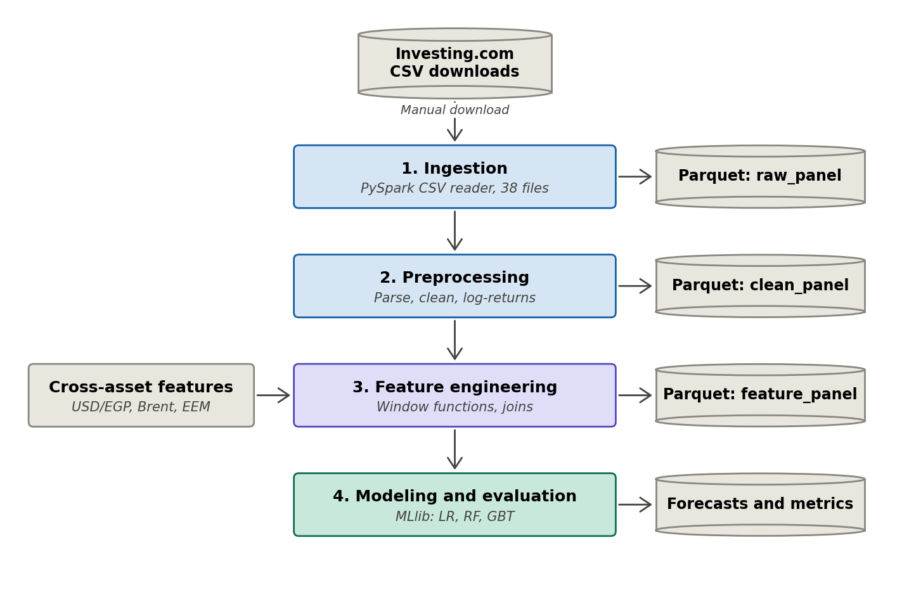
Fig. 2. Data lifecycle: acquisition, ingestion, preprocessing, feature engineering, and modeling, with Parquet checkpoints (cylinders) between every stage.
Acquisition is performed by downloading historical data from Investing.com’s public export, renaming each file to a ticker-based identifier, and uploading to HDFS at /egx/raw/. Ingestion uses PySpark to read each CSV under a uniform schema, attaching ticker, asset_class, and sector columns from an in-notebook manifest, after which all DataFrames are unioned into a long-format panel.
Preprocessing performs six normalization operations: parsing dates from US format (MM/DD/YYYY) into ISO date objects; numeric parsing of price columns containing comma thousand separators; expansion of volume suffixes (K, M, B) into raw integers; percent-sign removal in the Change Percent column; explicit annotation of trading halts including the approximately two-month closure of the EGX in early 2011; and conversion to log-returns space to eliminate level effects from the 2016, 2022, and 2024 currency-devaluation events. Working in log-returns rather than absolute prices is standard practice in the volatility-forecasting literature [5] and avoids the need for ad hoc level-shift adjustments. The cleaned panel is written to Parquet.
Data security and privacy considerations are minimal in this project because the dataset consists entirely of public market data with no personally identifiable information or licensed proprietary feeds. Two engineering safeguards are nonetheless applied: the GitHub repository excludes the raw CSV files from version control to avoid redistributing Investing.com’s data (a documented download script is provided instead), and the HDFS storage layer remains entirely on the local Docker cluster and is not exposed to any external network.
D. Feature Engineering
The feature panel is built using Spark Window functions partitioned by stock and ordered by date. Six families of features are computed.
Lagged realized volatility at five, ten, twenty, and sixty-day horizons forms the core autoregressive signal, exploiting the well-documented persistence of volatility regimes. Lagged log-returns over multiple windows capture short-term return momentum and reversal patterns. Volume-relative-to-rolling-mean ratios capture liquidity surges that often precede volatility events. High-low range statistics over recent windows provide an alternative volatility estimator (the Parkinson estimator [7]) that is robust to overnight gaps. Cross-asset volatility features merge USD/EGP, Brent crude, and the MSCI EM benchmark series into each stock’s panel via partition-aware joins, capturing exogenous spillover effects that are particularly important in Egypt’s open emerging-market context. Sector-level aggregate volatility, computed via groupBy on a sector-classification column, captures sector-wide common factors. Finally, calendar features including day of week, end-of-month indicators, and a Ramadan-period flag capture seasonal effects specific to the local market.
In total, approximately twenty-five engineered features are produced per (stock, date) observation. The full feature catalog with formal mathematical definitions will be presented as a table in the Phase 3 deliverable.
E. Models
Four regression models are trained and compared. Three are trained directly within the Spark pipeline using MLlib (Stage 4a in Fig. 1). The fourth is a deep learning model trained outside Spark in PyTorch on the same Parquet feature panel (Stage 4b).
1) Linear Regression Baseline (Spark MLlib)
A regularized linear regression establishes a reference performance level. The model is fit with elastic-net regularization, with the L1/L2 mixing parameter and the regularization strength tuned via time-aware cross-validation. The linear baseline is informative because volatility persistence (today’s volatility predicts tomorrow’s) is itself a near-linear relationship; any model that fails to substantially beat a linear baseline is not capturing meaningful structure beyond persistence.
2) Random Forest (Spark MLlib)
The random forest regressor uses bootstrap-aggregated decision trees with random feature subsampling, providing variance reduction and natural feature-importance estimates. Random forests handle non-linearities and feature interactions without manual specification, which matters when the relationship between macroeconomic covariates and equity volatility is regime-dependent.
3) Gradient-Boosted Trees (Spark MLlib)
The gradient-boosted tree regressor (GBTRegressor in MLlib) builds an additive ensemble of shallow trees fit sequentially to the residuals of prior trees [6]. GBT typically delivers the best tabular-data performance in the MLlib family at the cost of longer training time. The hyperparameter grid covers tree depth (3, 5, 8), number of iterations (50, 100, 200), and learning rate (0.05, 0.1). Conservative settings (shallower trees, lower learning rate, and subsampling of training rows per tree) are required to avoid catastrophic overfitting across the 2024 EGP devaluation regime shift, which would otherwise produce extreme out-of-sample predictions and negative volatility outputs that violate the bounded-below nature of the target.
4) Long Short-Term Memory Network (PyTorch)
The LSTM model [9] is trained outside Spark using PyTorch. Unlike the tabular models, the LSTM consumes a sequence representation: for each (stock, date) prediction target, the model receives the last sixty days of feature vectors as a sequence and outputs the predicted next-five-day realized volatility. This gives the deep model access to fine-grained temporal patterns that the tabular models can only approximate through their lagged-feature encoding.
The architecture is a two-layer LSTM with a hidden dimension of 64, dropout of 0.2 between layers, followed by a fully connected output head. Training uses the Adam optimizer with a learning rate of 0.001, mean-squared-error loss, batch size of 256, and early stopping on a held-out validation slice of the training period. Sequences are constructed by partitioning the Parquet feature panel by ticker, sorting by date, and emitting sliding windows of length sixty. The validation set is the most recent twelve months of the training period (calendar year 2023), preserving chronological ordering and preventing look-ahead bias.
The choice of LSTM over alternative deep architectures (e.g. Transformer encoders) is motivated by the dataset scale: with approximately one hundred twenty thousand training observations, the inductive bias of recurrent models toward sequential locality is beneficial, while Transformer architectures typically require substantially larger training corpora to outperform LSTMs on this class of problem. A Transformer comparison is identified as future work in Section V.
5) Direction Classifier (Spark MLlib)
In addition to the four volatility regressors, a gradient-boosted tree classifier (GBTClassifier) is trained on the same feature panel to predict next-five-day price direction (the sign of the cumulative five-day forward return). Class weights are computed via inverse-frequency weighting from the training set to handle any class imbalance. The classifier serves a complementary role rather than a competitive one: it provides an empirical contrast between volatility magnitude prediction and direction prediction. The well-documented asymmetry between strong predictability of volatility and weak predictability of direction in emerging markets is itself a substantive finding of the study, consistent with the efficient-markets literature.
All four volatility models operate on the same engineered feature panel and predict the same target (next-five-day realized volatility, computed from log-returns). This design enables a controlled comparison: any performance difference reflects modeling choices rather than differences in data, features, or splits.
F. Evaluation Protocol
Evaluation uses a strict time-based train/test split: training data covers January 2010 through December 2023, test data covers January 2024 through May 2026. Random splitting is explicitly avoided because it leaks future information into the training process, a recurring methodological error in financial machine learning [8].
The primary metric is root-mean-square error (RMSE) of predicted next-five-day realized volatility against the realized value computed from out-of-sample log-returns. Secondary metrics include mean absolute error (MAE), out-of-sample coefficient of determination (R-squared), and per-sector error breakdowns. The naive baseline is twenty-day historical persistence: using the trailing twenty-day realized volatility as the forecast for the next five days. The success criterion is at least a twenty-percent RMSE reduction over this baseline, evaluated globally across all stocks and reported separately by sector. Per-stock case studies will be presented for selected high-error and low-error tickers in the Phase 3 results section.
IV. Results and Discussion
This section will present the experimental results of the volatility forecasting pipeline, including model comparisons, per-sector performance breakdowns, error analysis around macroeconomic events such as the 2024 currency devaluation, and discussion of practical implications for risk management. Content will be developed in the Phase 3 deliverable after model training is complete.
V. Conclusion
This section will summarize the findings of the project, discuss limitations of the approach, identify directions for future work (such as intraday data, additional emerging markets, real-time streaming via Spark Streaming, Transformer-based sequence models for direct comparison against the LSTM baseline, and graph-based feature representations capturing inter-stock dependencies), and reflect on the contribution to the academic and practitioner communities. Content will be developed in the Phase 3 deliverable.
References
[1] R. F. Engle, “Autoregressive conditional heteroscedasticity with estimates of the variance of United Kingdom inflation,” Econometrica, vol. 50, no. 4, pp. 987–1007, 1982.
[2] T. Bollerslev, “Generalized autoregressive conditional heteroskedasticity,” Journal of Econometrics, vol. 31, no. 3, pp. 307–327, 1986.
[3] M. Zaharia et al., “Apache Spark: a unified engine for big data processing,” Communications of the ACM, vol. 59, no. 11, pp. 56–65, 2016.
[4] X. Meng et al., “MLlib: machine learning in Apache Spark,” Journal of Machine Learning Research, vol. 17, no. 34, pp. 1–7, 2016.
[5] T. G. Andersen and T. Bollerslev, “Answering the skeptics: yes, standard volatility models do provide accurate forecasts,” International Economic Review, vol. 39, no. 4, pp. 885–905, 1998.
[6] J. H. Friedman, “Greedy function approximation: a gradient boosting machine,” Annals of Statistics, vol. 29, no. 5, pp. 1189–1232, 2001.
[7] M. Parkinson, “The extreme value method for estimating the variance of the rate of return,” Journal of Business, vol. 53, no. 1, pp. 61–65, 1980.
[8] M. L. de Prado, Advances in Financial Machine Learning. Wiley, 2018.
[9] S. Hochreiter and J. Schmidhuber, “Long short-term memory,” Neural Computation, vol. 9, no. 8, pp. 1735–1780, 1997.

